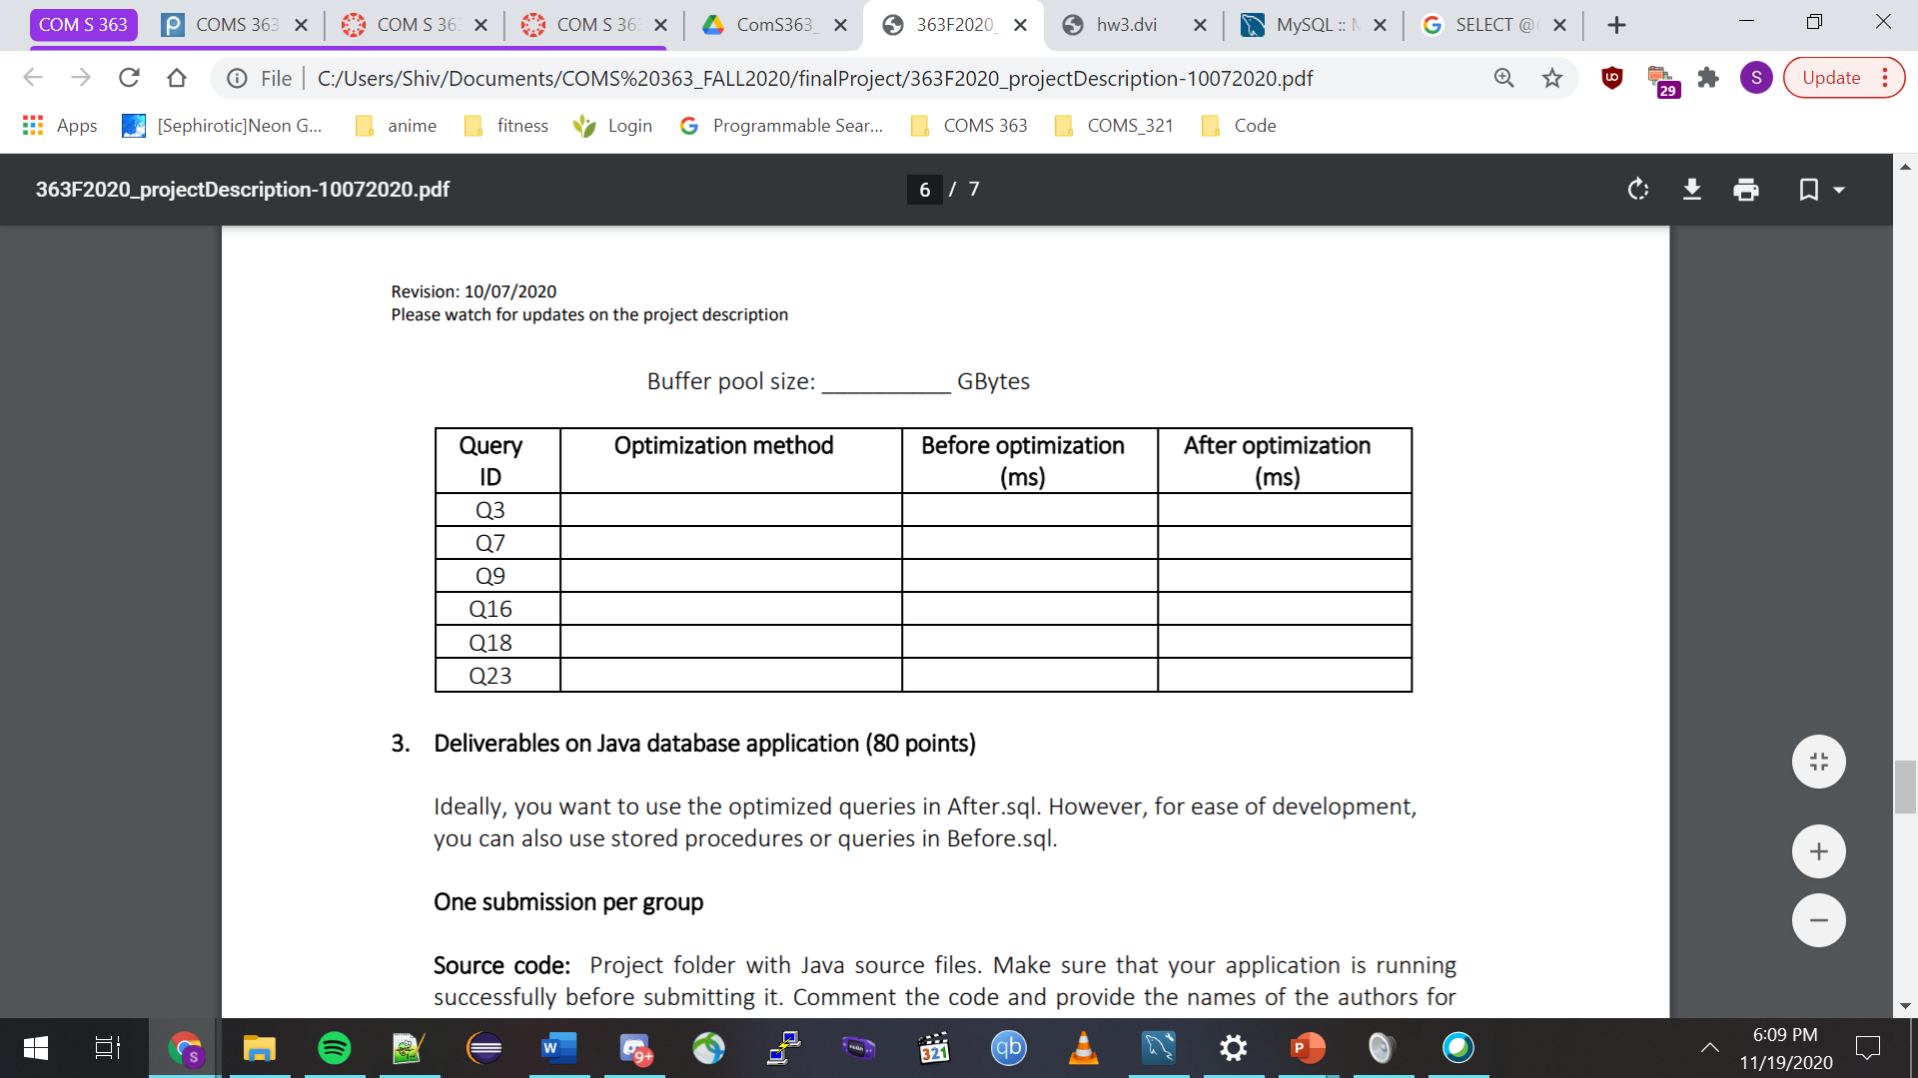

Created index on tweets (tid, user_screen_name, created_time)

4.06ms

12.4ms

193ms

284mss

109.4ms

215mss

87.4ms

303.2ms

296.8ms

6247msms

9.2ms

3.2ms

Increase buffer pool size from 8.38MB to 33.55MB

Increase buffer pool size from 8.38MB to 33.55MB

Created on users (subcategory)

Created index on hastags (hashtags_name, tweets_tid)

Increase buffer pool size from 8.38MB to 33.55MB